**Lab Exercise 2– .dockerignore in Docker**

**Name- Arshpreet Kaur**

**SAP ID- 500094140**

**B2, devops**

* **Create a Sample Project:**
* Create a simple project directory with various types of files, including source code, configuration files, and build artifacts.

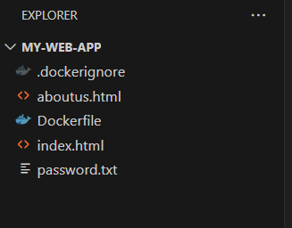

* **Create a Dockerfile:**
* Write a Dockerfile that specifies the build steps for your application, including any necessary dependencies.

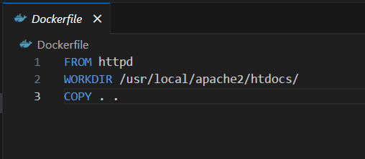

* **Create a .dockerignore File:**
* Create a .dockerignore file in the root directory of your project.
* Add specific files or directories to the .dockerignore file that you do not want to be included in the Docker image during the build process.

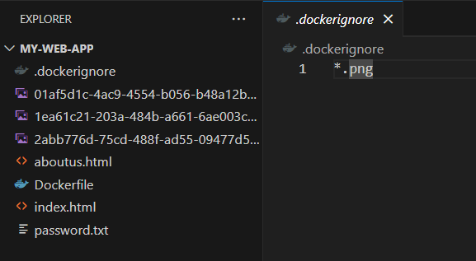

* **Build the Docker Image:**
* Use the docker build command to build the Docker image from the Dockerfile.
* Observe the build context and check which files are being included in the Docker image.

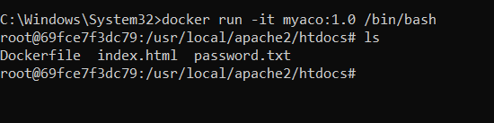

* **Modify .dockerignore and Rebuild:**
* Modify the .dockerignore file to exclude different types of files or directories from the Docker image.
* Rebuild the Docker image and observe the changes in the build context.

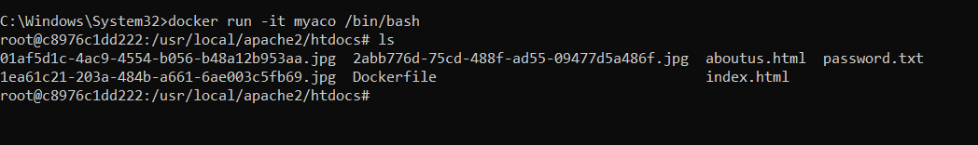

* **Test the Docker Image:**
* Run the Docker image as a container using the docker run command.
* Verify that the container works as expected, despite certain files being excluded from the Docker image.
* **Optimize the .dockerignore File:**
* Experiment with different patterns and wildcards in the .dockerignore file to optimize the build context and reduce the image size.
* **Check Image Size and Contents:**
* Use the docker image ls and docker image inspect commands to check the size of the Docker image and its contents.

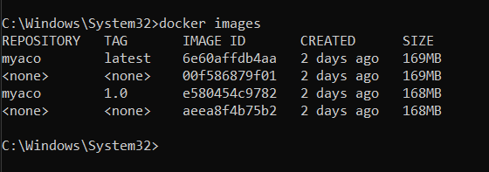

* **Update .dockerignore for CI/CD:**
* Modify the .dockerignore file to optimize the build context and reduce build times in a continuous integration and continuous deployment (CI/CD) pipeline.
* **Documentation and Best Practices:**
* Document your findings and the best practices for using the .dockerignore file in your projects.

.dockerignore file effectively to optimize Docker image builds and reduce image sizes.